EXPERIMENT 9: INTRODUCTION TO HONEYPOTS

AIM

To perform Linux file system forensics and identify evidence of a security breach.

PROCEDURE

- Investigate file system artefacts and user activities.
- Analyze suspicious files, permissions, and hidden data.
- Examine system files like /etc/passwd and user directories.
- Identify malicious binaries and reconstruct the attack timeline.

QUESTIONS

TASK 1 - Cowrie Demo

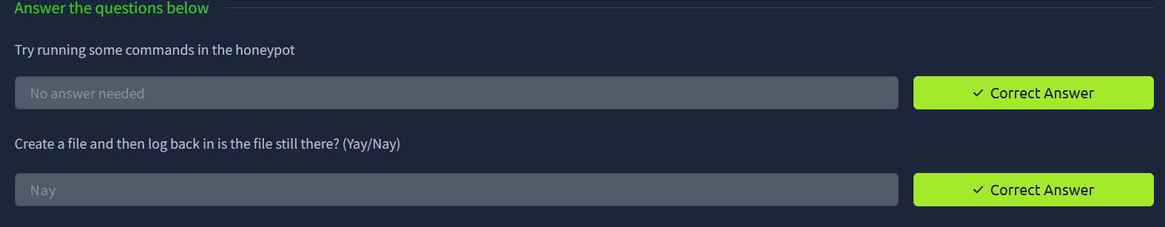

TASK 2 - Attacks against SSH

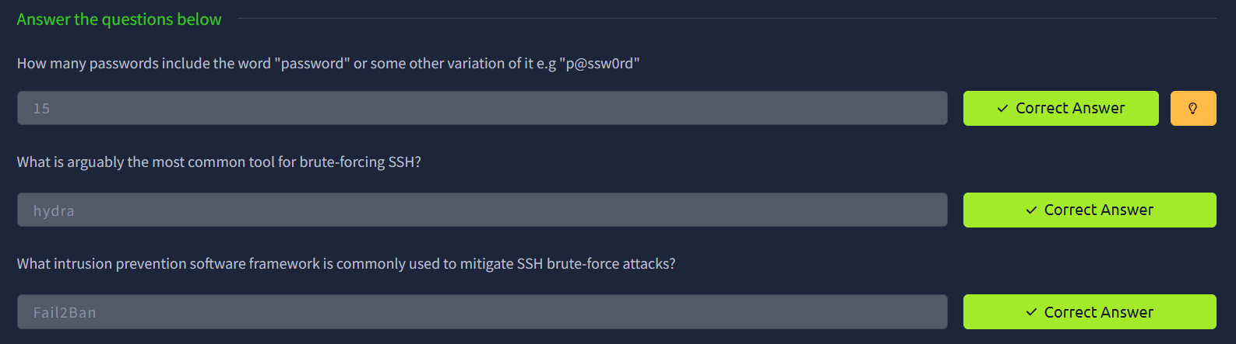

TASK 3 - Typical Bot Activity

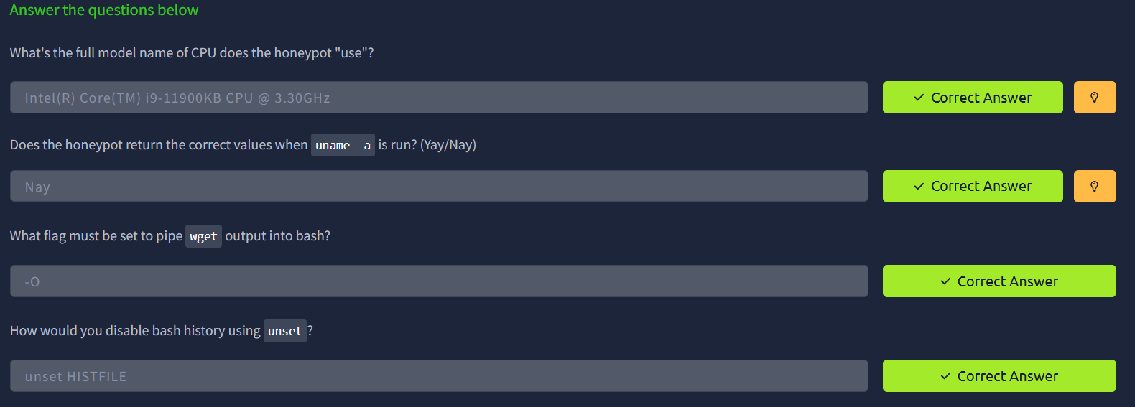

TASK 4 - Identification Techniques

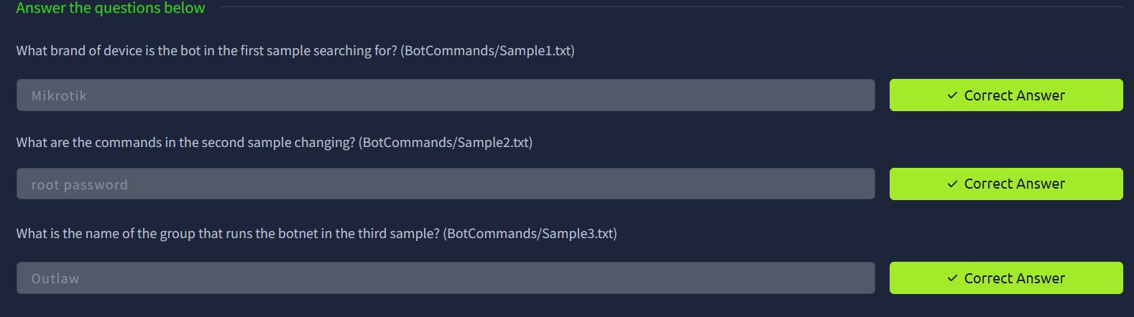

TASK 5 - SSH Tunneling

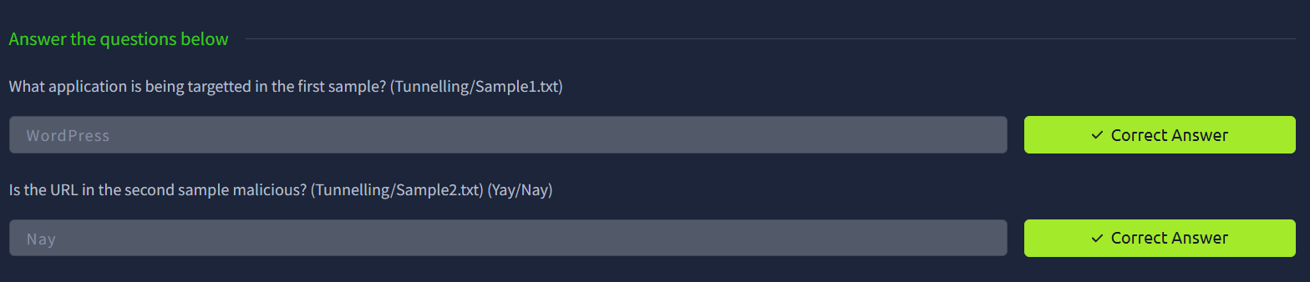

RESULT

Understood how honeypots capture attacker activity and help in analyzing threats and improving security defenses.

